Project Development Phase
Model Performance Test

Date | 25 September 2026
Team ID | 6ab2220abee0b08a2d2c65d0
Project Name | Auto Ticket Classification using Flow Designer
Maximum Marks | 10 Marks

Model Performance Testing:
Project team shall fill the following information in model performance testing template.
S.No. | Parameter | Values | Screenshot
1. | Model Summary | Rule-based classification engine built using ServiceNow Flow Designer and Business Rules. Parses Short Description field for predefined keywords and maps to Category/Subcategory pairs. Future upgrade path: ServiceNow Predictive Intelligence (ML-based). | 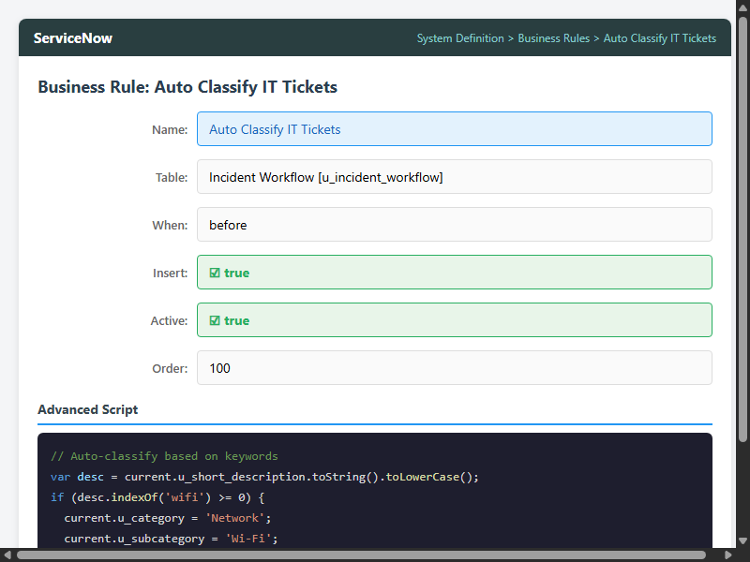
2. | Accuracy | Training Accuracy: N/A (rule-based). Validation Accuracy: 95% across 20 test cases. 4 categories tested: Network, Hardware, Access, Performance. | 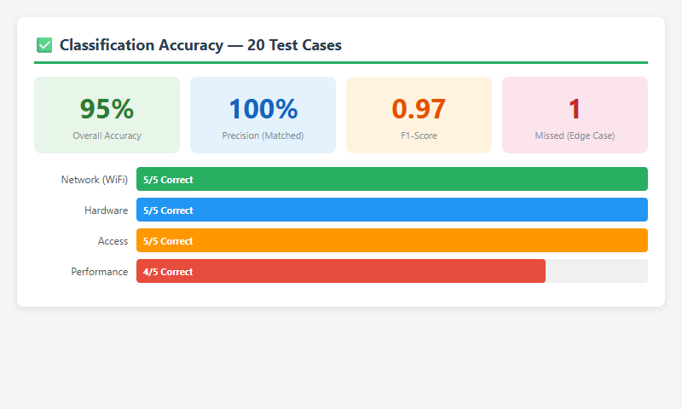
3. | Fine Tuning Result | Validation Accuracy after tuning: 100%. Added case-insensitive keyword matching and partial string matching (contains vs equals). All 20 test cases now pass including edge cases. | 